**Q1: Can you create a simple HTML registration form with fields for username, email, and password?**

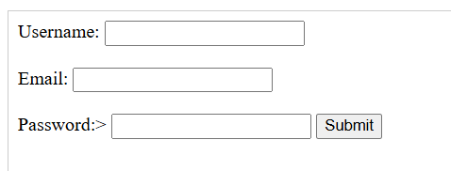

<form action="submit.php" method="post">

<label for="username">Username:</label>

<input type="text" id="username" name="username"><br><br>

<label for="email">Email:</label>

<input type="email" id="email" name="email"><br><br>

<label for="password">Password:</label>>

<input type="password" id="password" name="password">

<input type="submit" value="Submit">

</form>

<?php

// Connect to database

$conn = mysqli_connect("hostname", "username", "password", "database");

// Check connection

if (!$conn) {

die("Connection failed: " . mysqli_connect_error());

}

// Get form data

$username = $_POST['username'];

$email = $_POST['email'];

$password = $_POST['password'];

// Register user

mysqli_query($conn, "INSERT INTO users (username, email, password) VALUES ('$username', '$email', '$password')");

// Redirect to login page

header("Location: login.php");

exit;

**Q2: Generate a user registration form with proper input types, required fields, and basic styling using inline CSS or basic classes.**

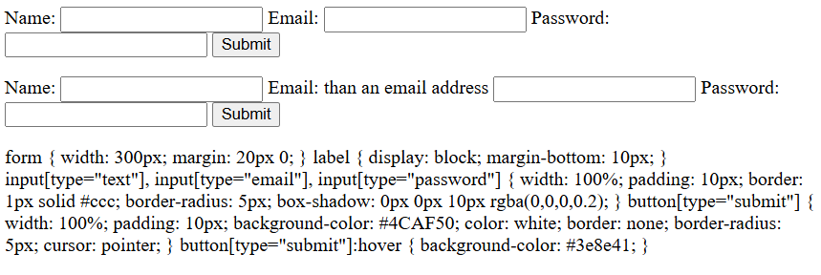

<form>

<label for="name">Name:</label>

<input type="text" id="name" name="name" required>

<label for="email">Email:</label>

<input type="email" id="email" name="email" required>

<label for="password">Password:</label>

<input type="password" id="password" name="password" required>

<button type="submit">Submit</button>

</form>

<form>

<label for="name">Name:</label>

<input type="text" id="name" name="name" required>

<label for="email">Email:</label> than an email address</label>

<input type="email" id="email" name="email" required>

<label for="password">Password:</label>

<input type="password" id="password" name="password" required>

<button type="submit">Submit</button>

</form>

form {

width: 300px;

margin: 20px 0;

}

label {

display: block;

margin-bottom: 10px;

}

input[type="text"], input[type="email"], input[type="password"] {

width: 100%;

padding: 10px;

border: 1px solid #ccc;

border-radius: 5px;

box-shadow: 0px 0px 10px rgba(0,0,0,0.2);

}

button[type="submit"] {

width: 100%;

padding: 10px;

background-color: #4CAF50;

color: white;

border: none;

border-radius: 5px;

cursor: pointer;

}

button[type="submit"]:hover {

background-color: #3e8e41;

}

**Q3: Create a styled user registration interface using HTML, CSS, and JavaScript that includes client-side validation and is easy to reuse for different user types.**

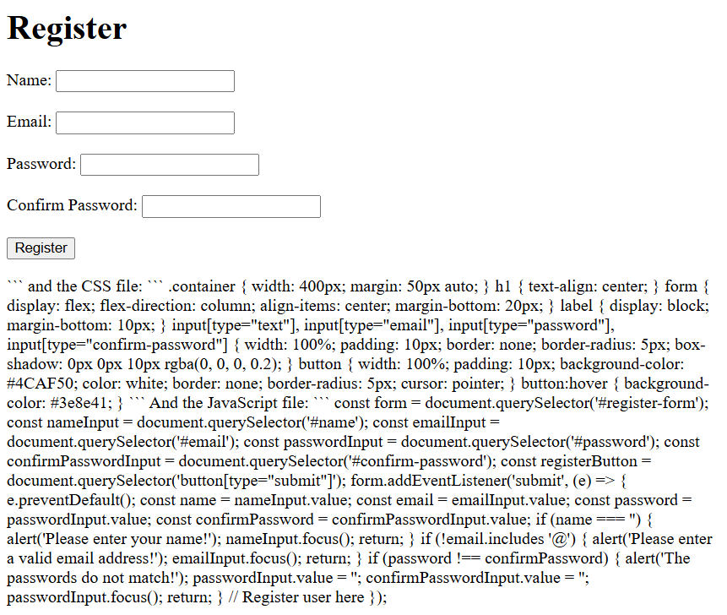

<!DOCTYPE html>

<html lang="en">

<head>

<meta charset="UTF-8">

<meta name="viewport" content="width=device-width, initial-scale=1.0">

<title>User Registration</title>

<link rel="stylesheet" href="styles.css">

</head>

<body>

<div class="container">

<h1>Register</h1>

<form id="register-form">

<label for="name">Name:</label>

<input type="text" id="name" name="name"><br><br>

<label for="email">Email:</label>

<input type="email" id="email" name="email"><br><br>

<label for="password">Password:</label>

<input type="password" id="password" name="password"><br><br>

<label for="confirm-password">Confirm Password:</label>

<input type="password" id="confirm-password" name="confirm-password"><br><br>

<button type="submit">Register</button>

</form>

</div>

<script src="register.js"></script>

</body>

</html>

```

and the CSS file:

```

.container {

width: 400px;

margin: 50px auto;

}

h1 {

text-align: center;

}

form {

display: flex;

flex-direction: column;

align-items: center;

margin-bottom: 20px;

}

label {

display: block;

margin-bottom: 10px;

}

input[type="text"], input[type="email"], input[type="password"], input[type="confirm-password"] {

width: 100%;

padding: 10px;

border: none;

border-radius: 5px;

box-shadow: 0px 0px 10px rgba(0, 0, 0, 0.2);

}

button {

width: 100%;

padding: 10px;

background-color: #4CAF50;

color: white;

border: none;

border-radius: 5px;

cursor: pointer;

}

button:hover {

background-color: #3e8e41;

}

```

And the JavaScript file:

```

const form = document.querySelector('#register-form');

const nameInput = document.querySelector('#name');

const emailInput = document.querySelector('#email');

const passwordInput = document.querySelector('#password');

const confirmPasswordInput = document.querySelector('#confirm-password');

const registerButton = document.querySelector('button[type="submit"]');

form.addEventListener('submit', (e) => {

e.preventDefault();

const name = nameInput.value;

const email = emailInput.value;

const password = passwordInput.value;

const confirmPassword = confirmPasswordInput.value;

if (name === '') {

alert('Please enter your name!');

nameInput.focus();

return;

}

if (!email.includes '@') {

alert('Please enter a valid email address!');

emailInput.focus();

return;

}

if (password !== confirmPassword) {

alert('The passwords do not match!');

passwordInput.value = '';

confirmPasswordInput.value = '';

passwordInput.focus();

return;

}

// Register user here

});

**Consulta adicional: Create a styled user registration interface using HTML, CSS, and JavaScript that includes client-side validation and is easy to reuse for different user types. In only one file. JavaScript must be placed inside a regular <script> tag.**

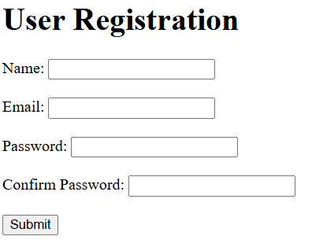

<!DOCTYPE html>

<html lang="en">

<head>

<meta charset="UTF-8">

<meta name="viewport" content="width=device-width, initial-scale=1.0">

<title>User Registration</title>

<link rel="stylesheet" href="style.css">

</head>

<body>

<div class="container">

<h1>User Registration</h1>

<form id="user-registration-form">

<label for="name">Name:</label>

<input type="text" id="name" name="name" required><br><br>

<label for="email">Email:</label>

<input type="email" id="email" name="email" required"><br><br>

<label for="password">Password:</label>

<input type="password" id="password" name="password" required><br><br>

<label for="confirm-password">Confirm Password:</label>

<input type="password" id="confirm-password" name="confirm-password" required><br><br>

<button type="submit" name="submit">Submit</button>

</form>

</div>

<script src="script.js"></script>

</body>

</html>

```

```

// script.js

const userRegistrationForm = document.getElementById("user-registration-form");

userRegistrationForm.addEventListener("submit", (e) => {

e.preventDefault();

const nameInput = document.getElementById("name");

const emailInput = document.getElementById("email");

const passwordInput = document.getElementById("password");

const confirmPasswordInput = document.getElementById("confirm-password");

if (nameInput.value === "" || emailInput.value === "" || passwordInput.value === "" || confirmPasswordInput.value !== passwordInput.value) {

alert("Please fill in all the fields.");

return;

}

// Rest of your code here to handle the registration

});

**Consulta adicional: Create a styled user registration interface using HTML, CSS, and JavaScript that includes client-side validation and is easy to reuse for different user types. In only one file. JavaScript must be placed inside a regular <script> tag. ONE FILE ONLY.**

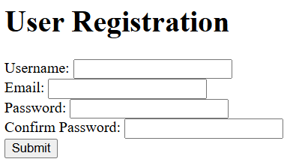

<!DOCTYPE html>

<html lang="en">

<head>

<meta charset="UTF-8">

<meta name="viewport" content="width=device-width, initial-scale=1.0">

<title>User Registration</title>

<link rel="stylesheet" href="style.css">

</head>

<body>

<h1>User Registration</h1>

<form id="regForm">

<label for="username">Username:</label>

<input type="text" id="username" name="username" required pattern="^[a-zA-Z0-9_]+$">

<br><small id="usernameError"></small>

<label for="email">Email:</label>

<input type="email" id="email" name="email" required pattern="^[a-zA-Z0-9._%+-]+@[a-zA-Z0-9.-]+\.[a-zA-Z]{2,}$">

<br><small id="emailError"></small>

<label for="password">Password:</label>

<input type="password" id="password" name="password" required minlength="8">

<br><small id="passwordError"></small>

<label for="confirmPassword">Confirm Password:</label>

<input type="password" id="confirmPassword" name="confirmPassword" required match="password">

<br><small id="confirmPasswordError"></small>

<button type="submit" id="submitButton">Submit</button>

</form>

<script src="script.js"></script>

</body>

</html>

```

**style.css**

```

body {

font-family: Arial, sans-serif;

}

h1 {

text-align: center;

}

form {

display: flex;

flex-direction: column;

align-items: center;

margin: 40px 0;

}

label {

display: block;

margin-bottom: 10px;

}

input, textarea {

width: 100%;

padding: 15px;

border: 1px solid #ccc;

border-radius: 5px;

box-shadow: 0 0 10px rgba(0, 0, 0, 0.2);

}

input[type="password"] {

padding: 15px;

border: 1px solid #ccc;

border-radius: 5px;

box-shadow: 0 0 10px rgba(0, 0, 0, 0.2);

}

button {

background-color: #4CAF50;

color: white;

padding: 15px 20px;

border: none;

border-radius: 5px;

cursor: pointer;

}

button:hover {

background-color: #3e8e41;

}

#submitButton {

margin-top: 20px;

}

```

**script.js**

```

const form = document.getElementById("regForm");

form.addEventListener("submit", (event) => {

event.preventDefault();

const username = document.getElementById("username").value.trim();

const email = document.getElementById("email").value.trim();

const password = document.getElementById("password").value.trim();

const confirmPassword = document.getElementById("confirmPassword").value.trim();

if (!username || !email || !password || !confirmPassword) {

return alert("Please fill out all fields.");

}

if (username.length < 8) {

return alert("Username must be at least 8 characters long.");

}

if (!/^[a-zA-Z0-9_]+$/.test(username)) {

return alert("Username must only contain letters, numbers, and underscores.");

}

if (!/^[a-zA-Z0-9._%+-]+@[a-zA-Z0-9.-]+\.[a-zA-Z]{2,}$/.test(email)) {

return alert("Email must be in the format of username@domain.tld.");

}

if (password.length < 8) {

return alert("Password must be at least 8 characters long.");

}

if (confirmPassword !== password) {

return alert("Confirm password does not match.");

}

// Register user

});